 ORDER FORM



NAME



# PLAYING SHIRT - $10

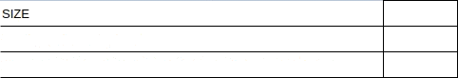

SHDRT or LONG SLEEVE

(if requiring both a long and short sleeve shirt write yes in box)

PREFERRED NAME ON BACK ( Surname or Nickname — Write in box below )



(playing number is allocated by club)

PANTS - $10



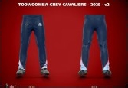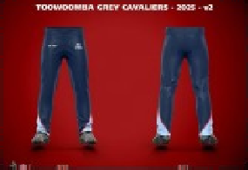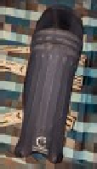

# TRAVEL SHIRT - $10

HELMET COVERS - $10



One size fits all

CLADS - $10



One size fits all

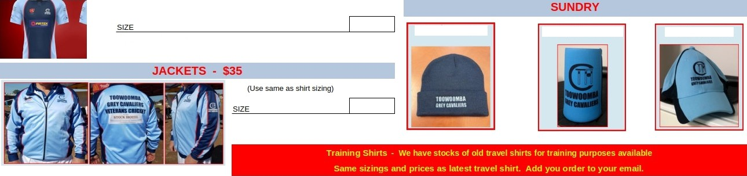

(All are short sleeve)

Beanies - $10

Stubby Holders -$5

Baseball caps - $10